ASSIGNMENT-7.3
Name:Hasini Irumalla
Ht.No:2303A51286
Batch:05
Task 1: Fixing Syntax Errors
Scenario
You are reviewing a Python program where a basic function definition contains a syntax error.
Requirements
• Provide a Python function add(a, b) with a missing colon
• Use an AI tool to detect the syntax error
• Allow AI to correct the function definition
• Observe how AI explains the syntax issue
Expected Output
• Corrected function with proper syntax
• Syntax error resolved successfully
• AI-generated explanation of the fix
Code: result = add(5, 3)
print(f"The result of add(5, 3) is: {result}")

result_negative = add(-1, 10)
print(f"The result of add(-1, 10) is: {result_negative}")
Output:The result of add(5, 3) is: 8
The result of add(-1, 10) is: 9
- Explanation: Intentional Error: A Python function add(a, b) was initially defined without the required colon, causing a SyntaxError: expected ':' when executed.
- Error Detection: The Python interpreter explicitly reported the SyntaxError, clearly indicating the missing colon.
- Correction: The function definition was corrected by adding the colon (def add(a, b):).
- Verification: The corrected function was then successfully executed and tested with example values.

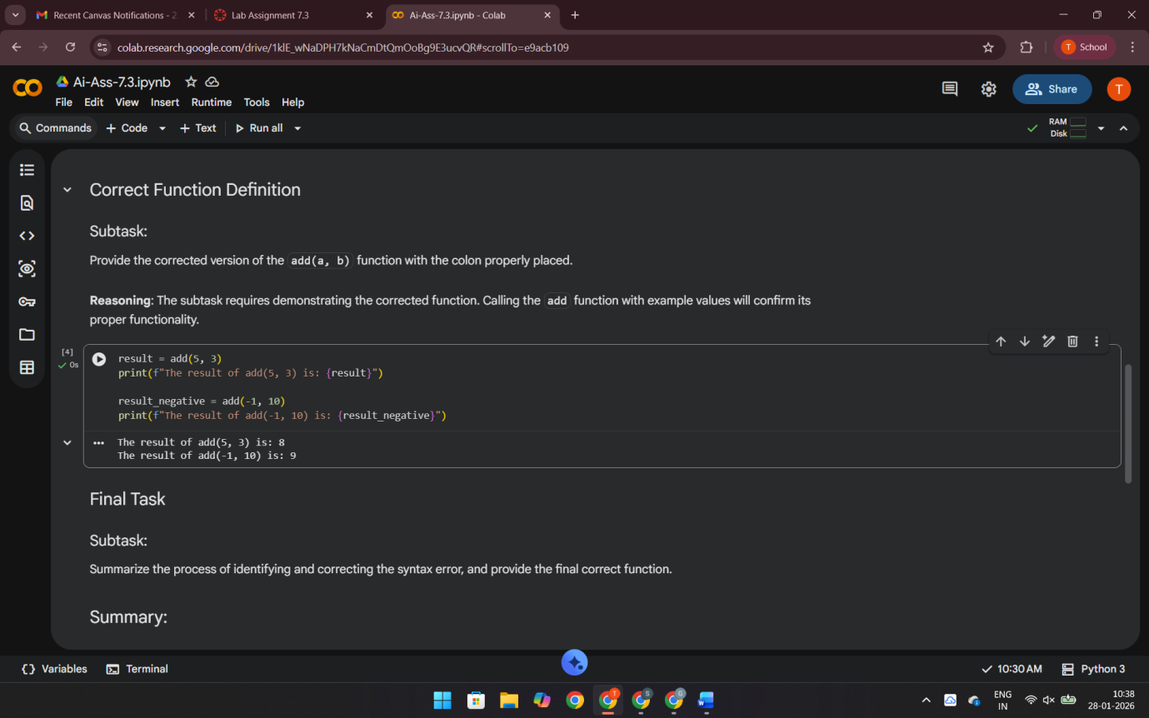
Task 2: Debugging Logic Errors in Loops
Scenario
You are debugging a loop that runs infinitely due to a logical mistake.
Requirements
• Provide a loop with an increment or decrement error
• Use AI to identify the cause of infinite iteration
• Let AI fix the loop logic
• Analyze the corrected loop behavior
Expected Output
• Infinite loop issue resolved
• Correct increment/decrement logic applied
• AI explanation of the logic error
Code: count = 0
while count < 5:
print(f"Current count: {count}")
count += 1
Output: Current count: 0
Current count: 1
Current count: 2
Current count: 3
Current count: 4
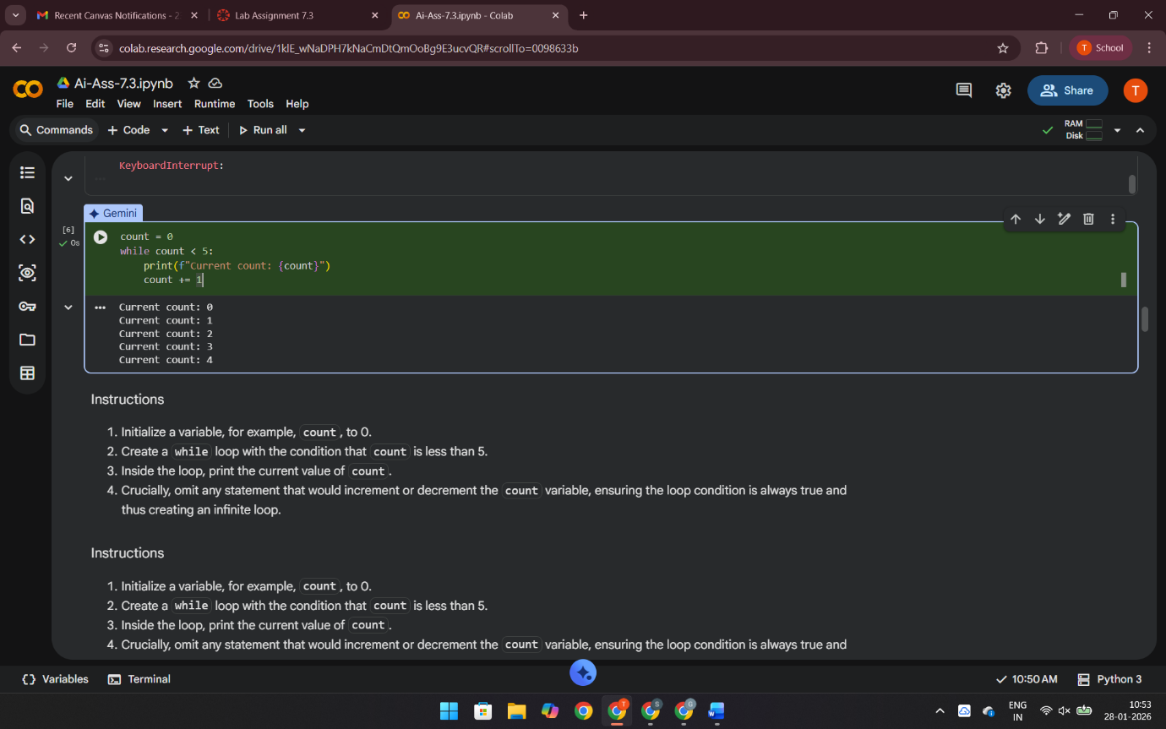
Explanation: We introduced an infinite loop by forgetting to increment the count variable in a while loop. This caused the loop condition (count < 5) to always be true, printing "Current count: 0" repeatedly. We then corrected this by adding count += 1 inside the loop, which made it terminate correctly and print counts from 0 to 4. This highlights the importance of modifying loop control variables to ensure termination.
Task 3: Handling Runtime Errors (Division by Zero)
Scenario
A Python function crashes during execution due to a division by zero error.
Requirements
• Provide a function that performs division without validation
• Use AI to identify the runtime error
• Let AI add try-except blocks for safe execution
• Review AI’s error-handling approach
Expected Output
• Function executes safely without crashing
• Division by zero handled using try-except
• Clear AI-generated explanation of runtime error handling
Code: def divide_safe(a, b):
try:
result = a / b
return result
except ZeroDivisionError:
return "Error: Cannot divide by zero"
except TypeError:
return "Error: Invalid input type"

# Example calls
print(divide_safe(10, 2))
print(divide_safe(10, 0))
print(divide_safe(10, "a"))
Output:
5.0
Error: Cannot divide by zero
Error: Invalid input type
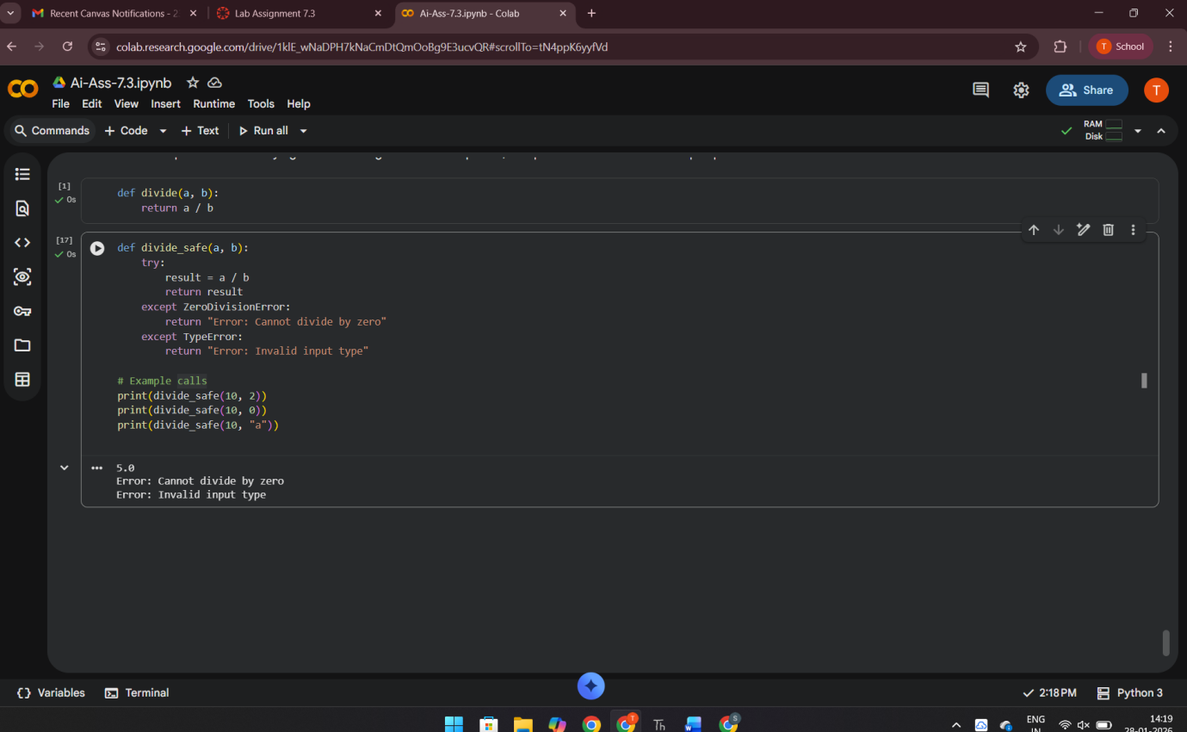
Explanation:
The original division function crashes when dividing by zero.
- AI identifies the runtime error as ZeroDivisionError.
- AI fixes it using try-except to prevent program failure.
- Error handling makes the code safer and more reliable.
- Using specific exceptions improves clarity and control.
Task 4: Debugging Class Definition Errors
Scenario
You are given a faulty Python class where the constructor is incorrectly defined.
Requirements
• Provide a class definition with missing self-parameter
• Use AI to identify the issue in the __init__() method
• Allow AI to correct the class definition
• Understand why self is required
Expected Output
• Corrected __init__() method
• Proper use of self in class definition
• AI explanation of object-oriented error
Code:
class Student:
def __init__(self, name, age):
self.name = name
self.age = age

s = Student("Ravi", 20)
print(s.name, s.age)
Output:Ravi 20
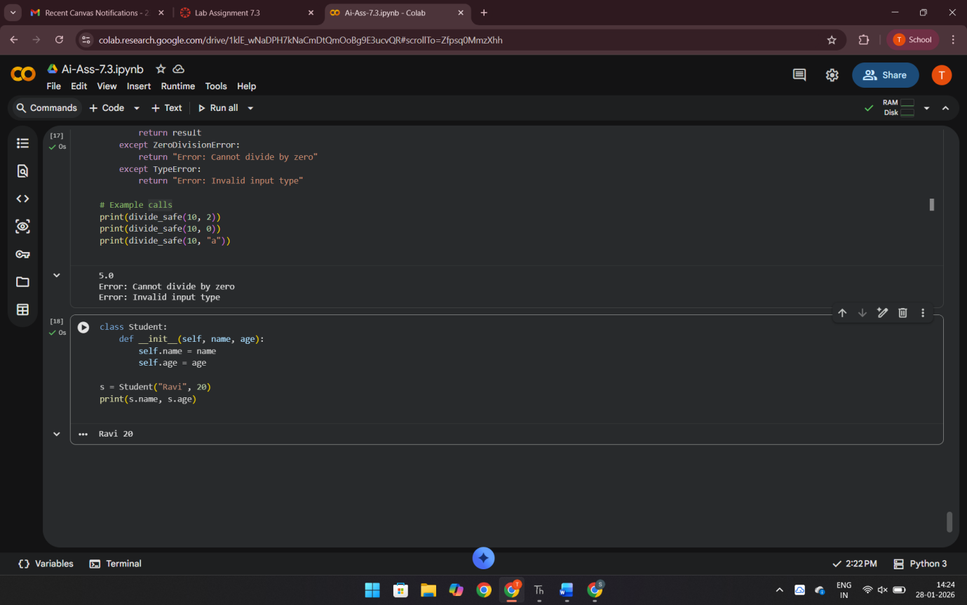
Explanation: self refers to the current object.
Without self, Python cannot store data inside the object.
AI identifies the missing self and fixes the constructor.
Using self.variable correctly binds data to the object.
Task 5 : Task 5Resolving Index Errors in Lists
Scenario
A program crashes when accessing an invalid index in a list.
Requirements
• Provide code that accesses an out-of-range list index
• Use AI to identify the Index Error
• Let AI suggest safe access methods
• Apply bounds checking or exception handling
Expected Output
• Index error resolved
• Safe list access logic implemented
Code: numbers = [10, 20, 30]

try:
print(numbers[5])
except IndexError:
print("Error: Index out of range")
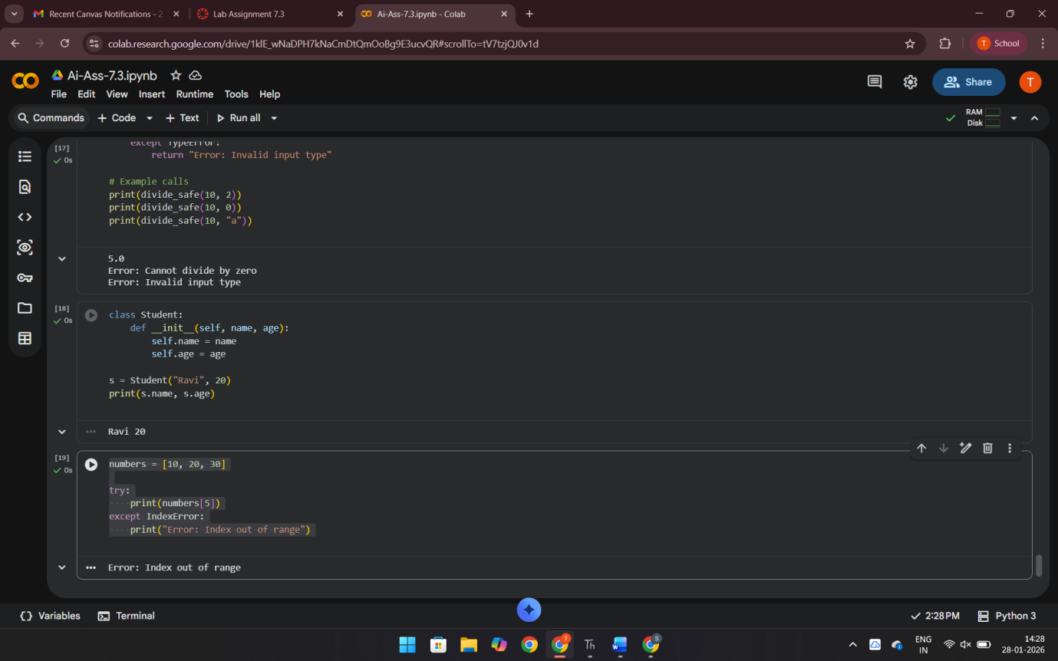

Output:Error: Index out of range
Explanation: Accessing an invalid index causes IndexError.
AI detects the error and prevents program crash.
try-except or bounds checking ensures safe list access.
This makes the program stable and error-free

